Write up – Ana Carolina das Neves Silva da Hora

Notebook Analysis
I am a difficulty in starting the installation of my environment without the administrator of the access, when it was not possible to access the jupyter notebook, I asked for help through live help and the mentor Pacencia in explaining the problem to me, from the project project.

Describe in your writeup how you modified the process_image() to demonstrate your analysis and how you created a worldmap. Include your video output with your submission.]

I found problems related to creating new files, I restored the github code RoboND master but I could not solve it, I started to study about the movie.py library but I ended up reinstalling my simulator. It worked but the creation of my video is very slow, I saw that the dimension that we recorded of the simulator influences a lot in the processing of the images.

Links help me: http://www.scipy-lectures.org/packages/scikit-image/
http://www.pyimagesearch.com/2014/08/25/4-point-opencv-getperspective-transform-example/

perception_step() and decision_step() functions have been filled in and their functionality explained in the writeup.

I've been studying python for a while now and I already have a certain notion of using classes, as I study computer science here in Brazil at the Pontificia Universidade Catolica in Rio de Janeiro, and I've already studied a subject called basic software, which deals with Low level in development, I used the C language and learned a lot about bit usage, bitwise and everything else so I tested the use in perception, trying to generate a certain fidelity in the code. My code in the first test with 1024x768 could not recognize anything which made me a bit frustrated.

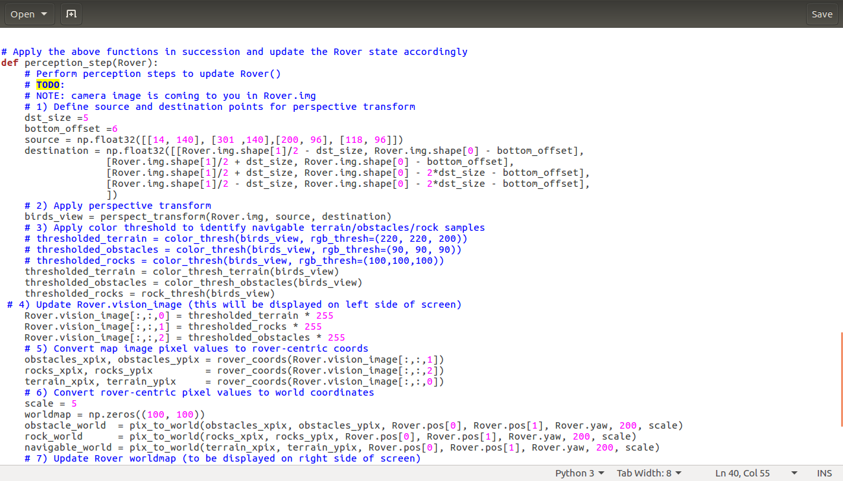

In decision.py I found a certain difficulty because all the algorithms of decisions that I tested the cart did not respond, sometimes my logic was wrong, for delivery I decided to follow with the "spoiler" given in the video but I intend to reissue the project, because I want to try To use the algorithm A * and maybe there is my difficulty in trying directly to use this algorithm in the decision making.

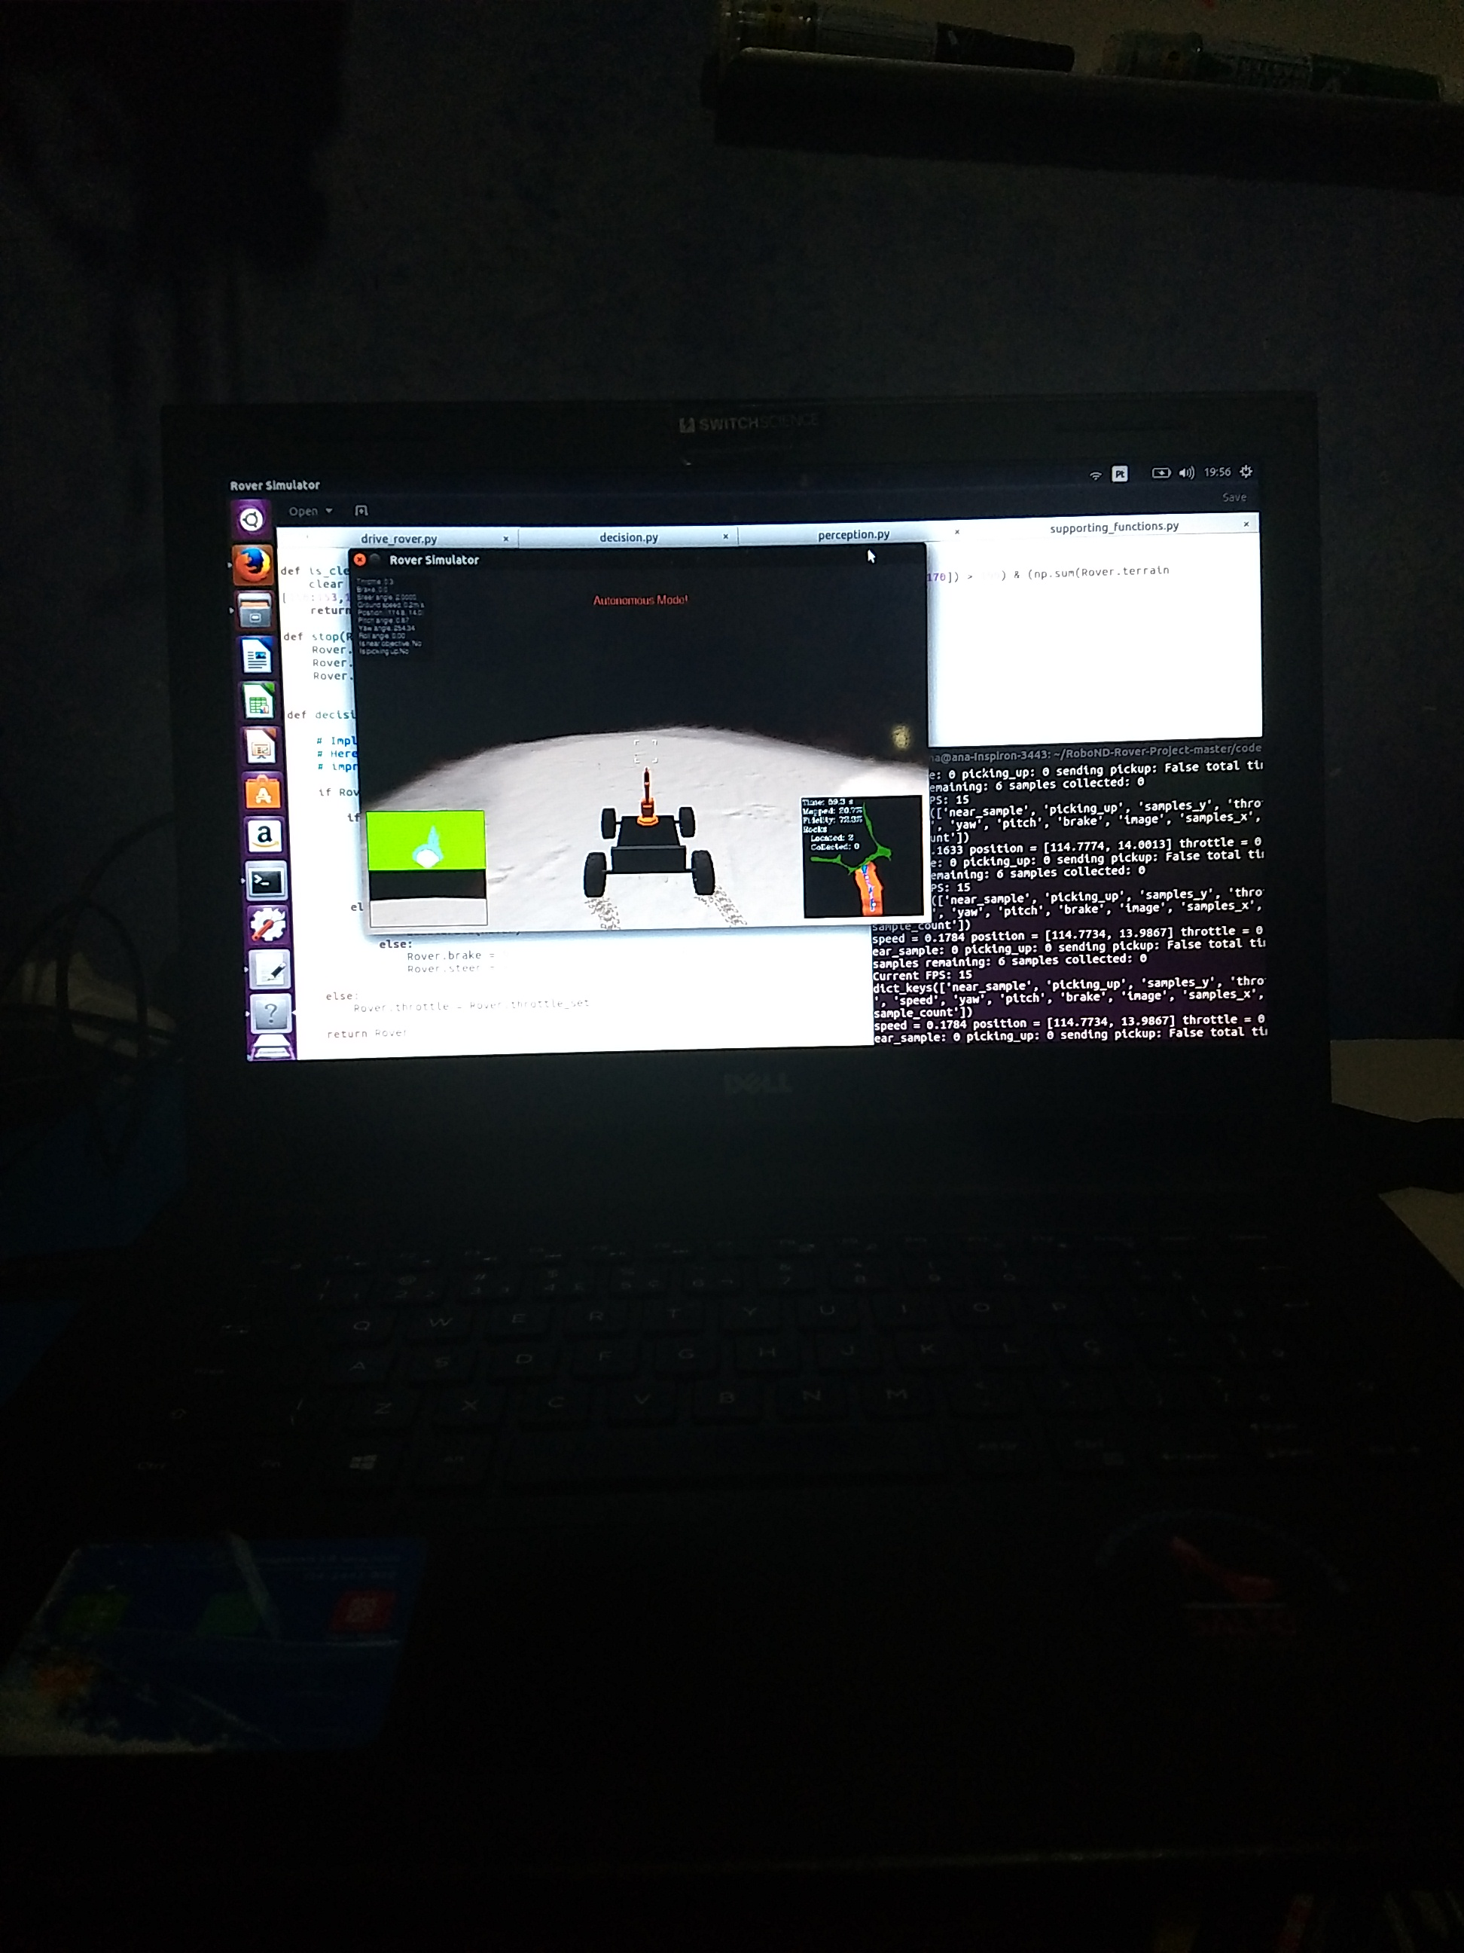
By running drive_rover.pyand launching the simulator in autonomous mode, your rover does a reasonably good job at mapping the environment.

I tested it with 1024x768 and ran beautifully 25 frames per second. In standalone mode I realized that very high resolution impairs the visibility of the project on my laptop. I tested with 800x600 And I noticed that ground speed slows down

This challenge was great for me, please, much work with robotics and artificial intelligence and with every mistake I want to solve as quickly as possible, learning the patience and the key to knowledge. It was in law to know that it is a nasa challenge, I looked for more about it, because I did not know it.
Need to improve my map a bit, I want to put the different cores, collect as rocks and improve my decision making, I believe that using the algorithm A * will be a challenge for me and also a huge learning. I sure will use the slack to get a lot of questions about.
Note: running the simulator with different choices of resolution and graphics quality may produce different results, particularly on different machines! Make a note of your simulator settings (resolution and graphics quality set on launch) and frames per second (FPS output to terminal by drive_rover.py) in your writeup when you submit the project so your reviewer can reproduce your results.

